School Bus Program
Eligibility guide for families
This leaflet will help explain the School Bus Program and assist you in determining your child’s eligibility to travel on a school bus.
While parents/guardians are primarily responsible for getting their children to and from school, the School Bus Program assists families in rural and regional Victoria by transporting students to school. The School Bus Program services both government and non-government schools.
Categories of eligibility determine whether a student travels at no cost or travels upon the payment of a fare. Students wishing to access a seat on a bus must complete an application form and parents/guardians must agree to the conditions of travel including, if applicable, the payment of a fare.
The Student Transport Unit of the Department of Education (DE) sets the policy and provides general transport advice to regional offices and schools. The Department of Transport and Planning (DTP) administers the School Bus Program as directed by the policy.
To be eligible for a seat on a bus at no cost a student must:
- Attend their closest government school, according to year level, or closest appropriate non-government school, which is determined by the denomination of the school.
- Reside 4.8 km or more from the school; measured by the shortest practicable route from the student’s front gate to the school’s main entrance.
- Reside in Victoria.
Students with access to public transport within 1.6km of their home or closer than their nearest school bus service, cannot be approved for travel on the school bus. However, they may be eligible for transport assistance through the Conveyance Allowance Program. For more information visit: www.vic.gov.au (search ‘travelling to school’).

Is your child eligible for the school bus?
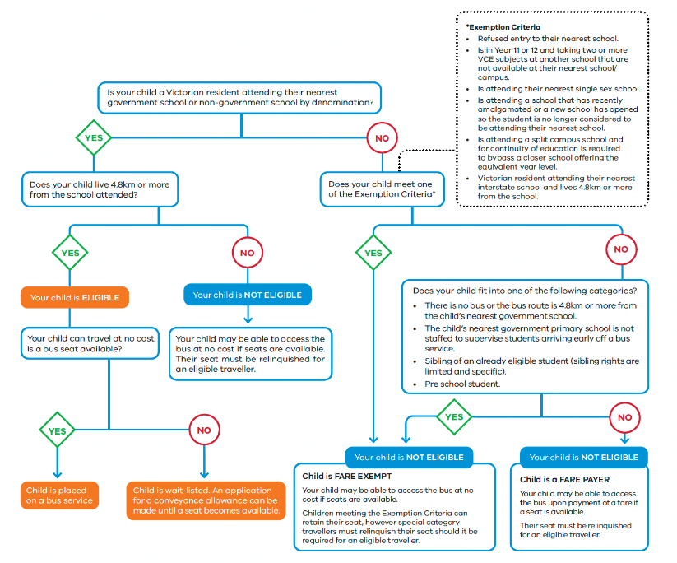
If your child has access to public transport within 1.6km of
home or nearer than the school bus, your child cannot be
approved for travel on the bus.

Notes

Non-government school students
- Eligible government students have priority over eligible non-government students when being accommodated on services.
- Non-government students may be accommodated where capacity exists.
- Non-government students on their own do not form a case for the establishment of a new school bus service or an extension to a route.

Ineligible students
- Government and non-government students not attending their closest appropriate school are required to pay a per term fare, regardless of the frequency of travel unless they meet one of the exemption criteria.
- A fare paying student may be required to relinquish their seat if the service is at capacity and an eligible non-fare paying student (government or non-government) wishes to access the service. The status of fare paying students is assessed each term.
- Parents/guardians must agree in writing that their child will travel as long as they pay a fare and seating capacity exists.
- Parents/guardians agree to make alternative travel arrangements should their child be required to relinquish their seat.
- Fare paying students do not form a case for the establishment of a new school bus service, service retention or an extension to the route.

Conditions of travel and parental responsibilities
- Students and parents/guardians must agree to comply with the conditions of bus travel as stated on the School Bus Program travel application forms.
- Parents/guardians are responsible for transporting their child to and from authorised bus stops and their safety while at the bus stop.
- Parents/guardians understand that school bus travel is a privilege and not a right.

Bus stops
- Bus stops are determined by the coordinating school and are based on appropriate locations that benefit as many travellers as possible to reduce travel time
- If a bus that stops near your home travels to a school other than your nearest, your child may be able to travel on it subject to seating capacity and upon payment of a fare
- Bus drivers are not permitted to carry students on the way to or from the start and end of a school run. For safety reasons, students must be picked up and dropped off at designated bus stops.

Special cases
- Families may apply for special consideration in complex and challenging transport circumstances. An application for special case consideration can be made through the school. Documentation that supports the case should be provided together with DE regional endorsement if a government school.

- Speak to your school’s bus coordinator for further information on special case consideration.

Emergency management
- In a forecast emergency school bus services will be cancelled if any part of the route is deemed at risk.
- A rapid onset emergency may result in service cancellations and buses being held at the school or if in transit, the buses returning to the school.
- Parents/guardians should familiarise themselves with the school’s school bus emergency management plans.

How to apply
- Please contact the bus coordinator at your child’s school for the appropriate school bus application form to complete and sign.
- Alternatively, you can download an application form online at: www.vic.gov.au (search ‘travelling to school’).
- If your school is in the School Bus Management System, you can apply online at: https://schoolbus.educationapps.vic.gov.au/
- You must complete a new application if your circumstances change (e.g. you move house or school)

Further information
Please visit: www.vic.gov.au (search ‘travelling to school’) or contact the bus coordinator at the school your child will be attending.

