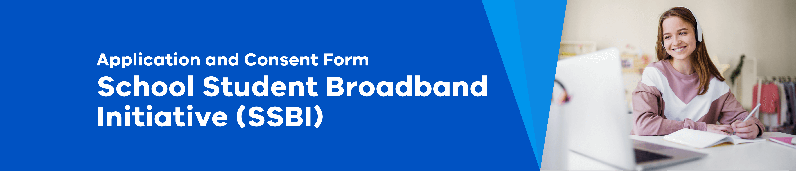

Privacy Notice: How We Collect and Use Personal Information
What is the School Student Broadband Initiative?
The SSBI is an Australian government initiative that offers free broadband internet access to eligible students for one year.

Why do we need your consent?
We need your consent to collect, use, and disclose personal information as part of the SSBI.

What documents or information do I need to provide when applying?
The only documentation required is the signing and returning of this consent form. No other documents are required.

What information will be collected and used?
We will collect and use the following information:
- Student's first name, last name
- Home address
- Confirmation of enrolment at the school
- Access to a computer device
- Parental consent via this form
Who will have access to the information?
School staff members (Principals, Assistant Principals, Business Managers) will have access to the information.

The department program team will also have access to student names (no other details). NBN Co will receive only addresses and a unique identification reference number.

How will the information be used?
Assessing eligibility for a voucher to access free broadband internet, or where otherwise permitted by law.

De-identified information will also be used by the department to:
- Inform decision and policy changes
- Inform stakeholders of research details and outcomes
- Improve the application process

How will your information be secured?
The department will protect your personal information, store it securely, and access will be limited to authorized personnel only. This in accordance with the Privacy and Data Protection Act 2014 (Vic), the Health Records Act 2001 (Vic) and the Public Records Act 1973 (Vic).

For more information visit our privacy policy at: www.vic.gov.au/privacy-vicgovau.

Your Consent
All form items are required to be completed
First name of student

Last name of student

Nominated address
This is the address where the NBN connection will be installed.

NBN Connection
We don’t currently have an NBN connection.

Device and safety
The student(s) has access to a device at home. They have the skills to use the internet safely or otherwise will be supervised when using the internet.

By signing this form, I agree that I have read and understood this form. I consent to [insert school name and email address] collecting, storing, and using information about myself and the student as described in this form.

First name of parent/guardian

Email address of parent/guardian
Last name of parent/guardian
Date

Further Information
If you have any questions or wish to request access or correction of personal information, please contact Wodonga Senior SC on 0260437500. For further information about how NBN Co handles personal information, please read their Privacy Policy on the nbn website at: www.nbnco.com.au/utility/privacy-policy.

